SANDHIYA S-ACE12362-TRAINEE
1. Azure Home page: search virtual machine in the search bar.
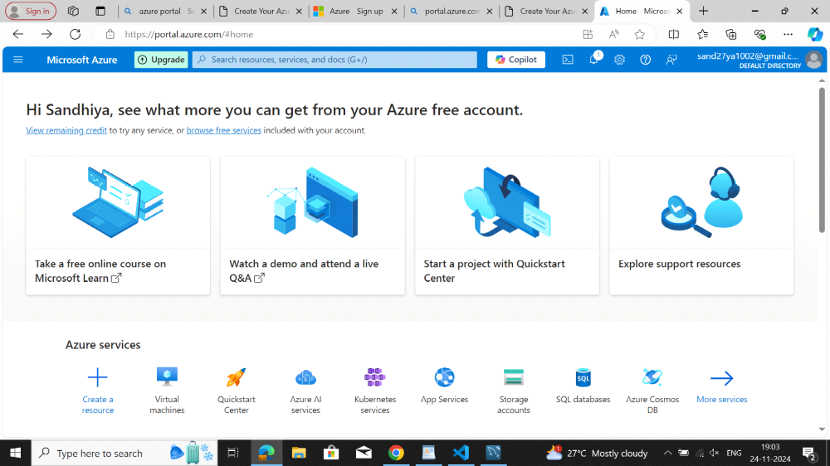

2. click create button
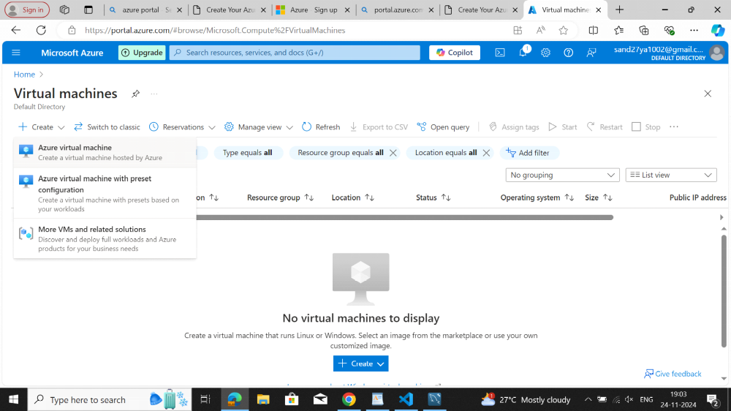
3. Select subscription as free trail and create resource group.
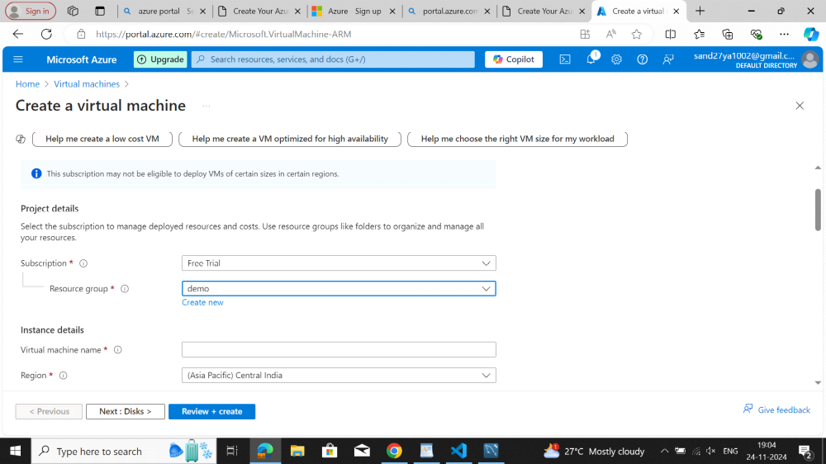
3.

3."demo" resource group has been created
4. Give the virtual machine name and select the region
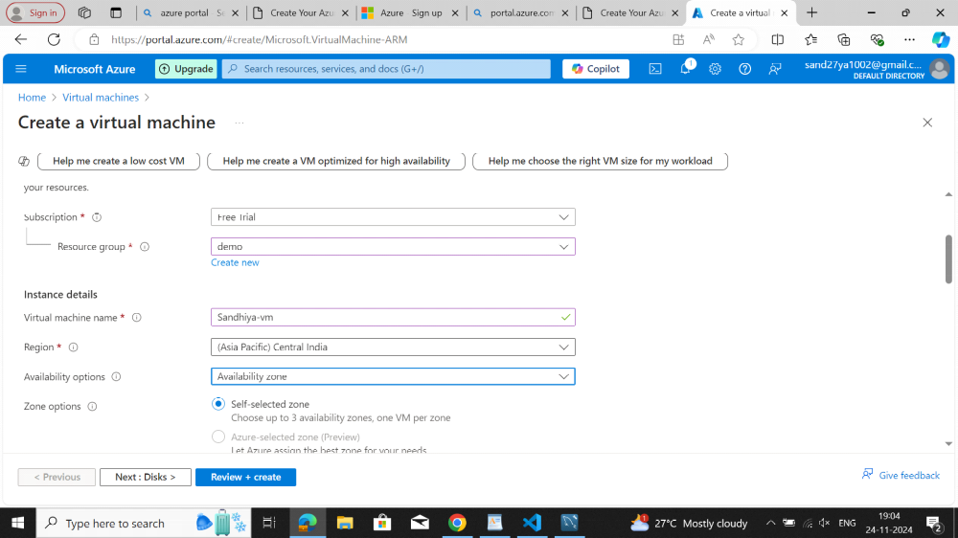
5. select the availability zone and image
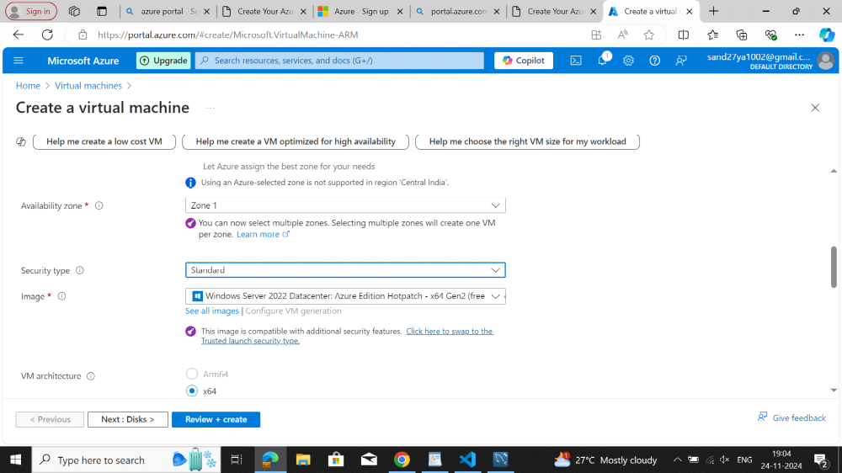
6. set administer credentials for virtual machine:
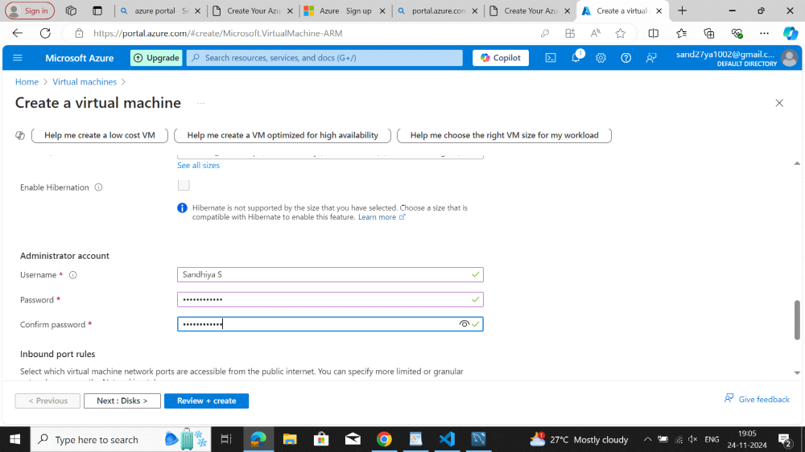
7. after giving all the details click review and create

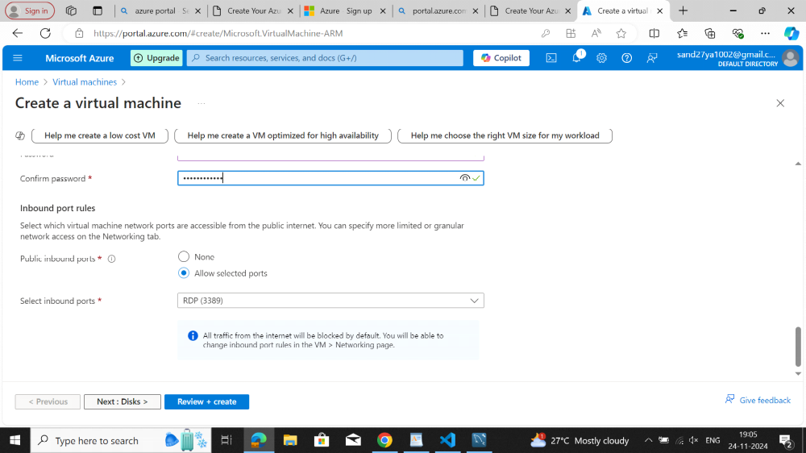
8. after reviwing the details click create.
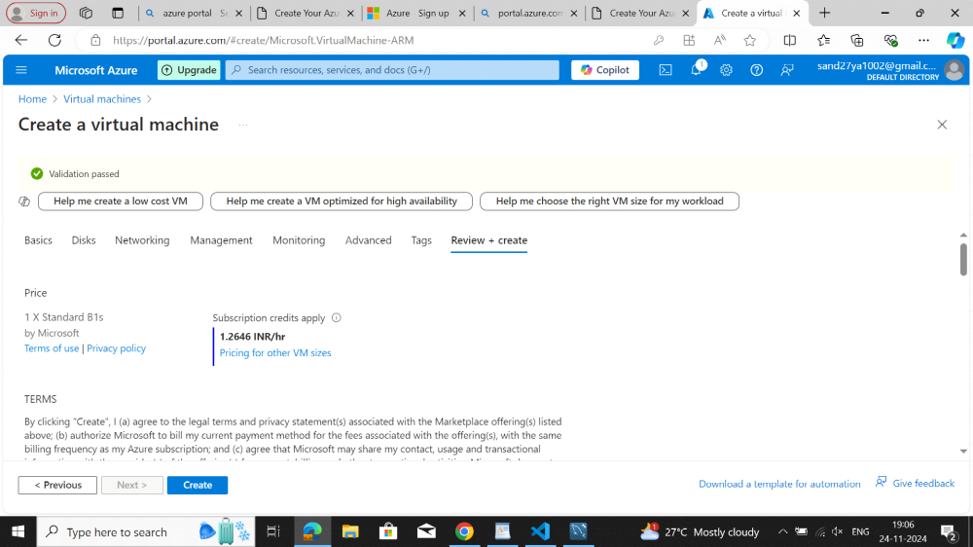
9. virtual machine is in deployment progress.
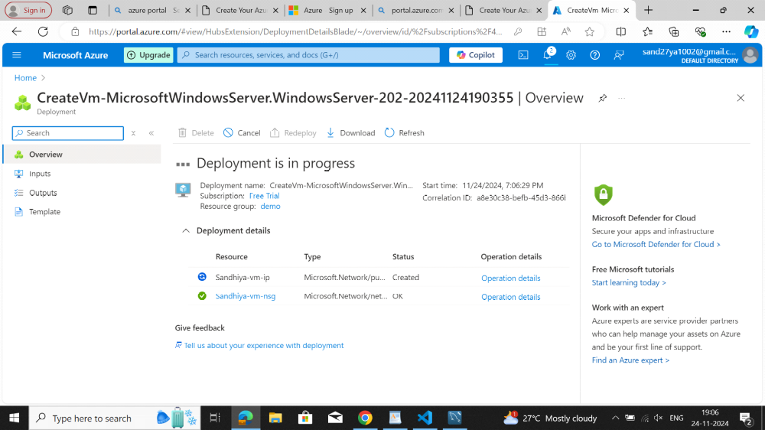
10. deployment is complete sucessfully.
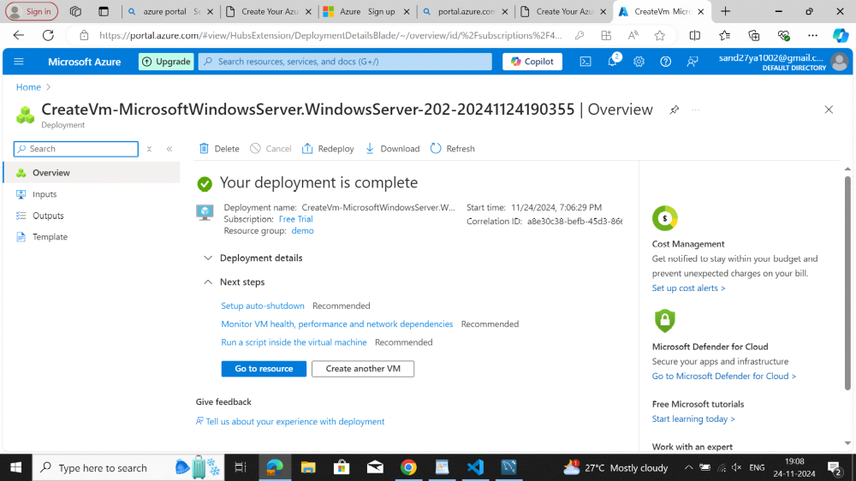
11. then click connect
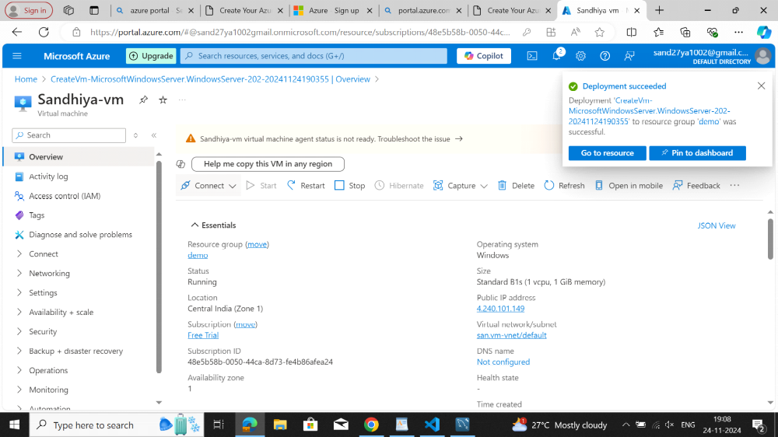
12. download the RDP file to connect with Remote desktop
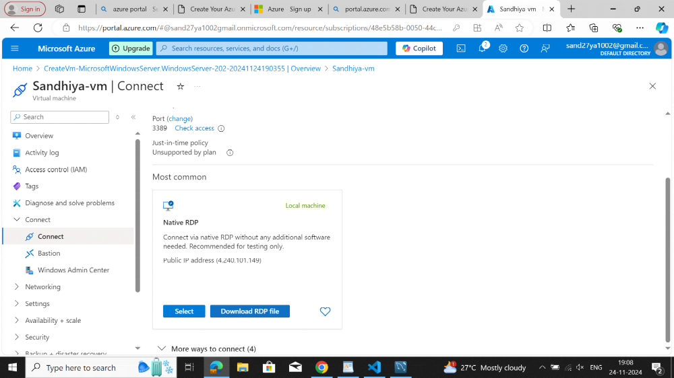
13. Click the downloaded rdp file
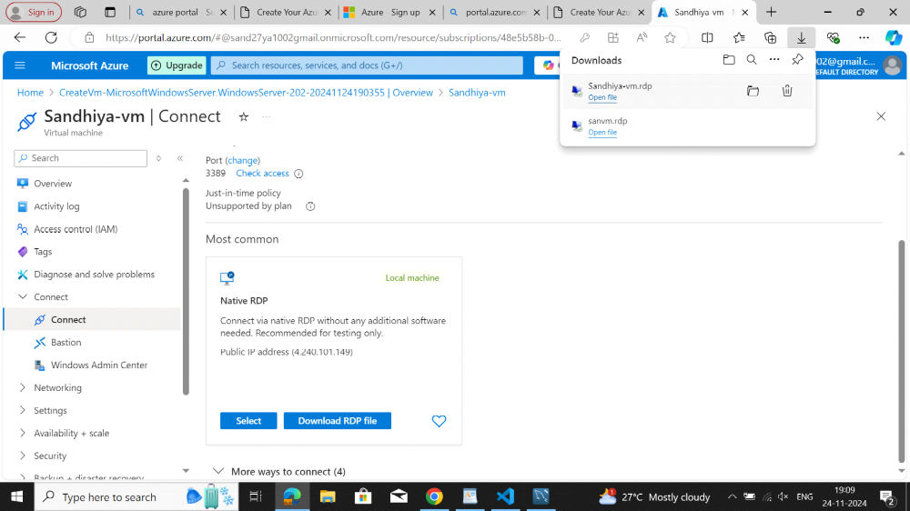
14. Click connect button
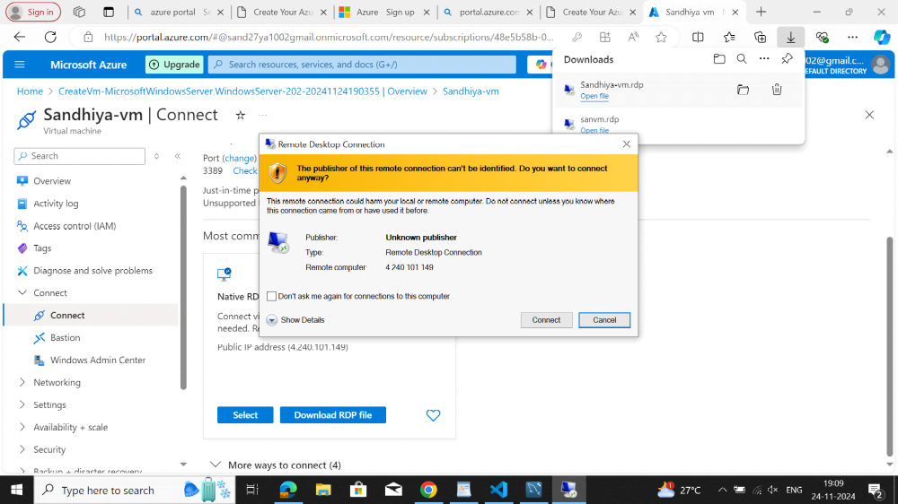
15. Give admistration creadentials .click ok.
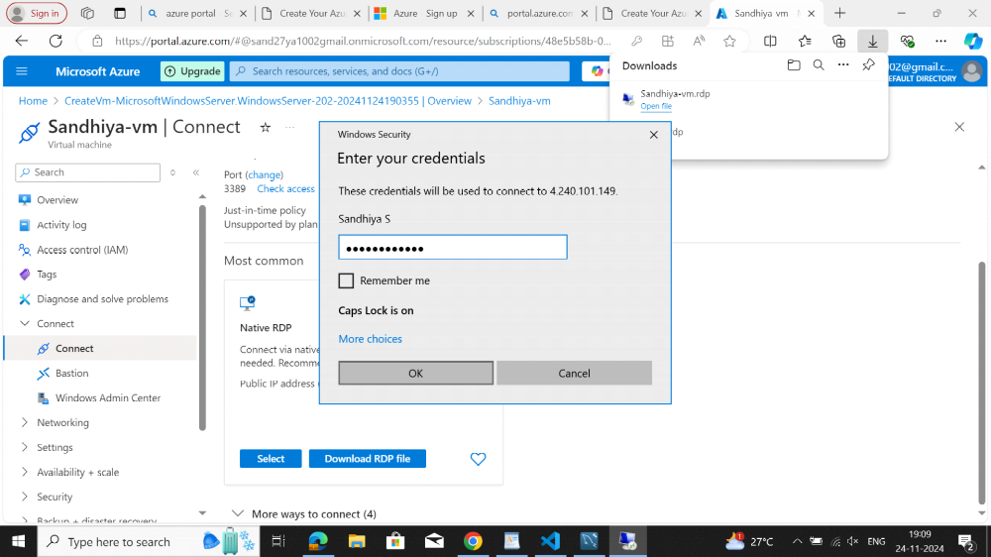
16. click "Yes " to connect then server will be launched.

